Stat 112
Fall 24 – Mahtash Esfandiari and Jiale Han
Assessment

Question Possible points Actual points

One 40 __________

Two 40 __________

Three 20 __________

Total 100 ___________

This is a closed book exam and you can have access to a cheat sheet written on front and back. You are not supposed to use the Internet or your phone.
Any misconduct will be reported to the Dean’s office and it will be dealt with based on university regulations.

Question one. Given table one, table two, and plot one, answer questions a to g. (35 points)
Definition of variables (data is about UCLA undergrads)
academicenvp = confidence in academic confidence
classcomfort= uncomfortable, somewhat comfortable, comfortable, very comfortable
welcomingenvp = feeling welcome
- Interpret the coefficient for very comfortable (bolded) within context. 5 points

- Interpret the coefficient of welcoming (bolded) within context. 5 Points

- State the question underlying plot one within context. 5 points

- Interpret plot one within context– 5 points

e. Interpret R-squared within context. 5 points

f. In multiple linear regression models they generally report MSE. What is MSE a measure of? 5 points

g. If you wanted to find MSE for m1, how would you do it? 5 points

Outputs for question one
Relevant Model
> model<-lm(academicenvp~classcomfort*welcomingenvp)
> summary(model)
Table one : classcomfort
uncomfortable somewhat comfortable very comfortable
380 1172 2913 910
Table two: Summary table resulting from the model
Coefficient | coefficient | Standard error | t -value | Pr(>|t|
Intercept | 38.70 | 1.63 | 23.74 | 0.000
Very comfortable | 13.88 | 3.81 | 3.64 | 0.000
comfortable | -3.78 | 3.26 | -1.16 | 0.174
Somewhat comfortable | 3.52 | 2.56 | 1.36 | 0.174
welcomingenvp | 0.30 | 0.02 | 13.02 | 0.000
very comfortable*welcoming | -0.01 | 0.05 | -0.23 | 0.816
Comfortable*welcoming | 0.07 | 0.07 | 1.50 | 0.133
Somewhat*welcomingp | -0.05 | 0.05 | -1.38 | 0.167
Residual standard error: 13.87 on 1974 degrees of freedom
Multiple R-squared: 0.2783, Adjusted R-squared: 0.2758
F-statistic: 108.8 on 7 and 1974 DF, p-value: < 2.2e-16

Plot one: Interaction effect between class comfort and feeling welcome

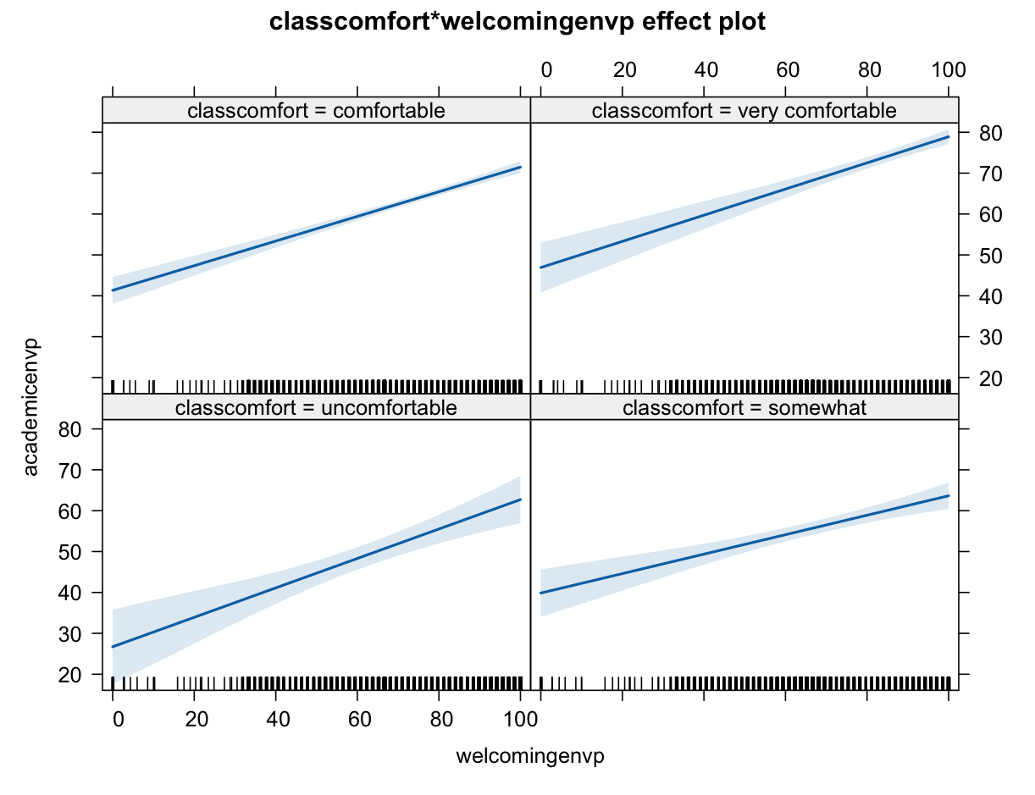
Question two. Given m0, m, table one, table two, table three, plot one, plot two, answer the following questions.

Variables of the study
Divrespectp = feeling of respect for diversity (numerical)
Excluengligh = feeling of exclusion on the basis of spoken English (No, Yes)
Exclurace = feeling of exclusion on the basis of spoken race (No, Yes)
Exclucountry = feeling of exclusion based on the country of origin (No, Yes)

> m0<-glm(exclurace~1,family="binomial")
> summary(m0)
Null deviance: 1267.4 on 938 degrees of freedom
Residual deviance: 1267.4 on 938 degrees of freedom
AIC: 1269.4

m1<-glm(exclurace~divrespectp+excluenglish*exclucountry,family="binomial")
Table one – output resulting from m1
> m1<-glm(exclurace~divrespectp+excluenglish*exclucountry,family="binomial")
> summary(m1)

Coefficients:
Estimate Std. Error z value Pr(>|z|)
(Intercept) 0.48185 0.30308 1.590 0.111866
divrespectp -0.01802 0.00399 -4.517 6.27e-06 ***
excluenglish1 1.22049 0.21272 5.738 9.60e-09 ***
exclucountry1 0.93199 0.25404 3.669 0.000244 ***
excluenglish1:exclucountry1 -0.06255 0.41573 -0.150 0.880396
---
Signif. codes: 0 ‘***’ 0.001 ‘**’ 0.01 ‘*’ 0.05 ‘.’ 0.1 ‘ ’ 1
Null deviance: 1267.4 on 938 degrees of freedom
Residual deviance: 1130.3 on 934 degrees of freedom

Question 2.1
Using m0 and m1, if you were the TA for this class, how would you explain the difference between null residual and model residual. 6 points.

Question 2.2 Given m1:
- What is the research question underlying m1? Please be within context. 5 points

- Interpret the 95% confidence interval of the odds for exclusion on the basis of spoken English WITHIN CONTEXT. (see table one – it is bolded) – 5 points

Question 2.3

- If you were to draw the plot of odds, which interval would you expect not to include one and why? 5 points

- Interpret 0.84 within context. 5 points
> exp( -0.01802*10) – notice that -0.01802 is from table one (it is bolded)
[1] 0.84

Table two. Table of odds, 95% confidence interval for odds, and P-value for the coefficient of m1
Predictor | odd | 95% CI for odd | p-value
Respect for diversity | 0.98 | 0.97-0.99 | 0.000
Exclusion on the basis of spoken English (Yes) | 3.39 | 2.24-5.17 | 0.000
Exclusion on the basis of country of origin (Yes) | 2.54 | 1.54 -4.19 | 0.000
Interaction between exclusion based on spoken language and country of origin | 0.94 | 0.41-2.14 | 0.880

Table three: The actual and the predicted (based on m1) number of UCLA students who felt exclusion on the basis of race.
Predicted value | Actual frequency of feeling excluded on the basis of race
Predicted value | No | Yes
No | 477 | 213
Yes | 82 | 167

Question 2.3 Given table three
- Compute accuracy of the model. Show your calculations. Find the final answer. 7 points

- Did the model do better with sensitivity or specificity? Choose one. 7 points

Sensitivity ________

Specificity _______
Explain why?

Question three: Given the following plot one, output one, and output two, answer the following questions. 15 points

Variables in the study:
Academicenvp = academic confidence (numerical) – This is the outcome
Friendlyenvp = friendliness of our environment (numerical)
Overallclimatep = overall UCLA climate (numerical)
Prejudicenvp = feeling of prejudice (numerical)
Firtgen = (yes,no)
gpa(categorical – 4 levels)
lowfamilyincomeindicator (Yes,no)

Plot one
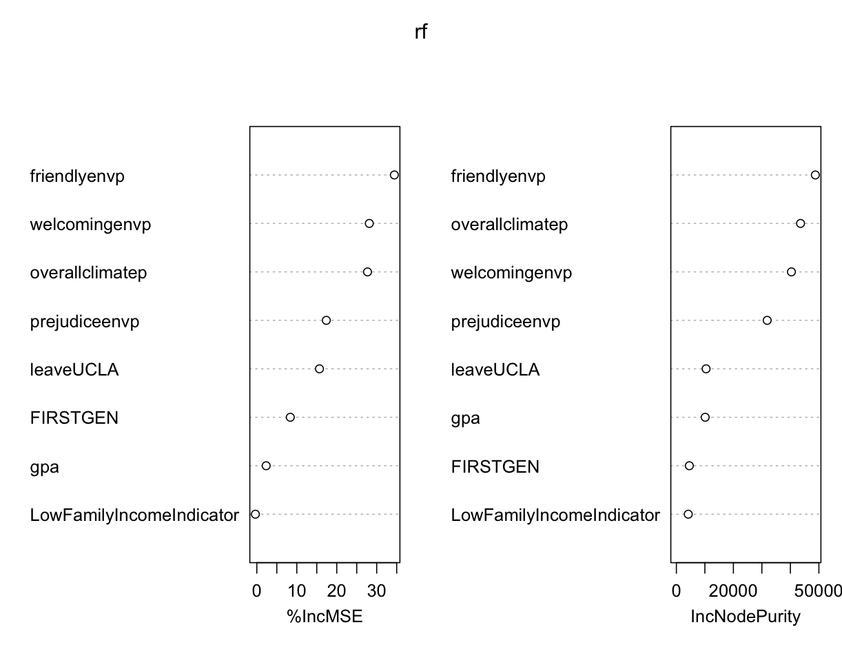
Model one
> model one<-lm(academicenvp~friendlyenvp+welcomingenvp+overallclimatep+prejudiceenvp+leaveUCLA+FIRSTGEN+gpa+LowFamilyIncomeIndicator)
> summary(m1)
Coefficients:
Estimate Std. Error t value Pr(>|t|)
(Intercept) 26.26467 4.50794 5.826 6.97e-09 ***
friendlyenvp 0.18798 0.03772 4.983 7.01e-07 ***
welcomingenvp 0.14510 0.02203 6.586 6.31e-11 ***
overallclimatep 0.24984 0.03106 8.044 1.80e-15 ***
prejudiceenvp -0.13607 0.03403 -3.999 6.68e-05 ***
leaveUCLAyes -5.99603 1.01437 -5.911 4.23e-09 ***
FIRSTGENyes 1.49963 0.80724 1.858 0.0634 .
gpa3 - 3.49 0.81395 1.01130 0.805 0.4210
gpa3.5 and above 1.26818 1.00601 1.261 0.2077
gpaBelow 2.49 -1.81451 1.65066 -1.099 0.2718
LowFamilyIncomeIndicatorNot Low Income -1.76750 0.77539 -2.279 0.0228 *
Residual standard error: 13 on 1449 degrees of freedom
Multiple R-squared: 0.3808, Adjusted R-squared: 0.3765,
Model two
> modeltwo<-lm(academicenvp~friendlyenvp+welcomingenvp+overallclimatep+prejudiceenvp+leaveUCLA)
> summary(m6)
Coefficients:
Estimate Std. Error t value Pr(>|t|)
(Intercept) 26.31595 4.44605 5.919 4.04e-09 ***
friendlyenvp 0.18508 0.03783 4.893 1.11e-06 ***
welcomingenvp 0.14032 0.02199 6.381 2.35e-10 ***
overallclimatep 0.25485 0.03111 8.191 5.62e-16 ***
prejudiceenvp -0.12879 0.03405 -3.783 0.000162 ***
leaveUCLAyes -6.28320 1.00773 -6.235 5.91e-10 ***

Residual standard error: 13.05 on 1454 degrees of freedom
Multiple R-squared: 0.3739, Adjusted R-squared: 0.3717

- What does plot one show? 5 points

- What do you conclude from it? 5 points

- If you were the statistician on this project, would you recommend model one or model two? Choose one. 10 points
Model one ______ Model two ______

Give two reasons why you choose one model one over model two or model two over model one.

